Program Wide Africa Rising Field Exchange Visit

Partners’ Reflections of the Field Exchange Visit

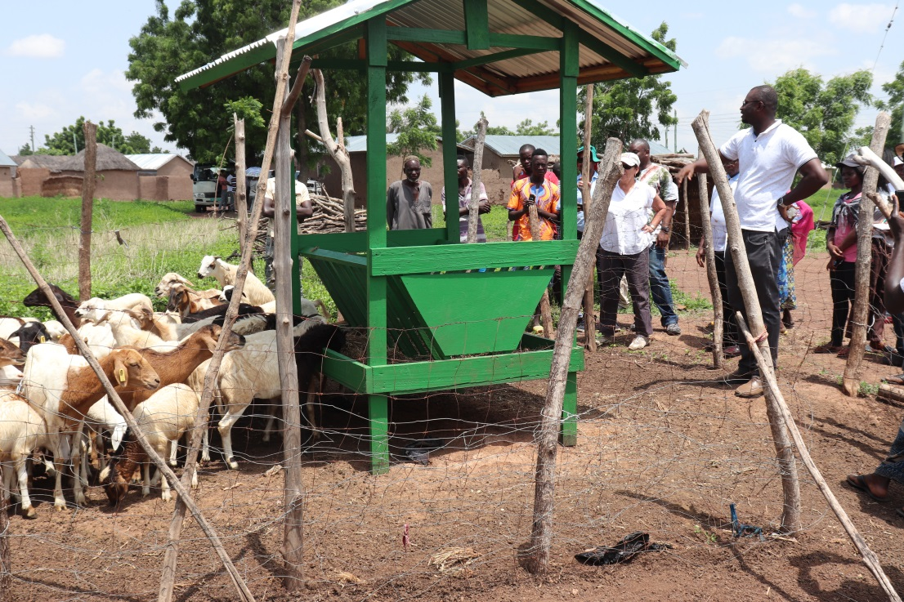

June 2019
www.africa-rising.net

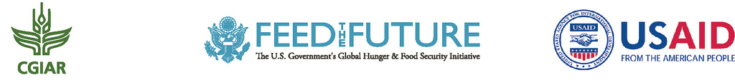

The Africa Research In Sustainable Intensification for the Next Generation (Africa RISING) program comprises three research-for-development projects supported by the United States Agency for International Development, as part of the U.S. government’s Feed the Future initiative.

Through action research and development partnerships, Africa RISING will create opportunities for smallholder farm households to move out of hunger and poverty through sustainably intensified farming systems that improve food, nutrition, and income security, particularly for women and children, and conserve or enhance the natural resource base.
The three regional projects are led by the International Institute of Tropical Agriculture (in West Africa and East and Southern Africa) and the International Livestock Research Institute (in the Ethiopian Highlands). The International Food Policy Research Institute leads the program’s monitoring, evaluation and impact assessment. http://africa-rising.net/

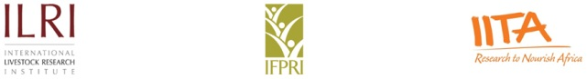
This document is licensed for use under the Creative Commons Attribution 4.0 International Licence.

This document was made possible with support from the American people delivered through the United States Agency for International Development (USAID) as part of the US Government’s Feed the Future Initiative. The contents are the responsibility of the producing organization and do not necessarily reflect the opinion of USAID or the U.S. Government

REFLECTIONS OF THE AFRICA RISING FIELD EXCHANGE VISIT

T
he Africa RISING project occasionally organizes Field Exchange Visits. Partners of the different sub-regions move to one selected sub-region to visit the Africa RISING intervention sites to share experiences on the technologies being practiced.
This year, the Exchange Visit took place in the Northern regions of Ghana. Partners from all three (3) sub-regions (East & Southern Africa, Ethiopia and West Africa) were present.
The field exchange visit had about 40 Africa RISING implementers from international and national research institutions in Ghana, Mali, Ethiopia, Malawi, Zambia and Tanzania. The partners also came from the various organizations / institutions that are working with the Africa RISING Program such as AMEDD, Bioversity, CIAT, CIMMYT, CSIR-SARI, ICRISAT, IITA, ILRI, IWMI, KNUST, LUANAR, SUA, UDS and WorldVeg.

The purpose of the visit was to exchange experiences and contribute to cross-program learning by Africa RISING implementers across the three mega regions (West Africa, East/Southern Africa, and Ethiopia) in the areas of livestock feeding, human nutrition, irrigated vegetable production, and soil and water management as well as mechanization.
Partners gathered to see what was going on at selected farming fields in both the Northern Region and Upper East Region of Ghana. They learnt lessons to take to their respective project countries and also contributed their ideas and thoughts at the respective sites they visited. . The exchange visits also serve to enrich the host projects and contribute towards regional harmonization of the work being conducted in Africa RISING.

Some of the partners had the pleasure to express and share their views and sentiments of the Exchange Visit and the respective details are provided below.

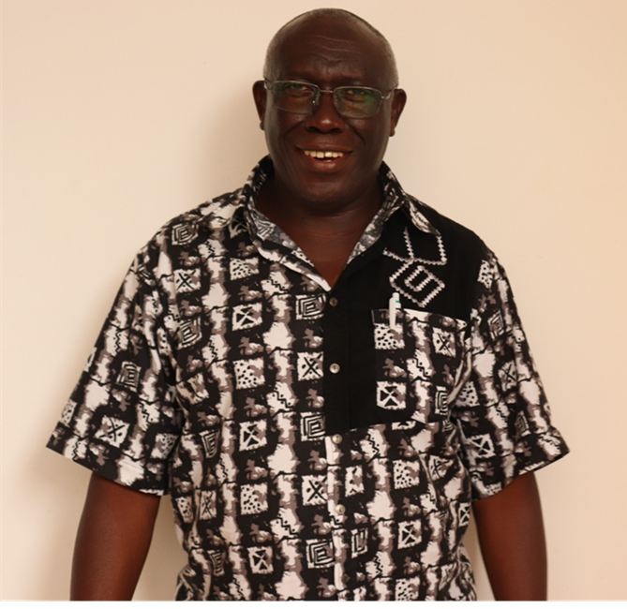

Prof Mateete Bekunda, Ugandan
Chief Scientist @ IITA, Tanzania
Africa RISING – East and Southern Africa region

Partners have met under different programs like the Learning Event that happened in Malawi in February 2019. Though the other programs also included field visits, this Field Exchange Visit program has been the first time that an Exchange Visit has been the sole aim.
I expected more of researcher to researcher engagement in the field. However, it was great to allow farmer participation.
During the Exchange Visit, my observation deduced that the interest/commitment to publish what has been achieved through experimentation needs to be strengthened further.
The logistical arrangements were commendable, as well as the open discussions.
In my opinion, the timing of the field visits, perhaps, could have been planned to coincide more with active field work, which brings out more appreciation of the functioning of technologies.
The Chief Scientists are working quite well as a team.

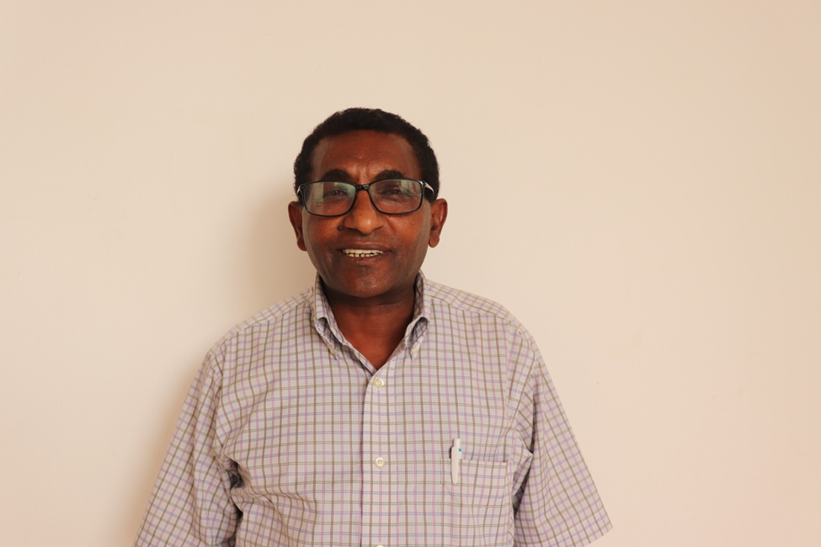

Dr. Kindu Mekonnen, Ethiopian
Lands & Water and Livestock @ ILRI, Ethiopia
Chief Scientist, Africa RISING – Ethiopian Highlands

I have participated in the Africa RISING Field Exchange Visit programs on several occasions. From experience, the previous Field Visit programs were very useful. I have learnt a lot from the interactions observations of the field trials. Also, my expectation for this Exchange Visit program has been achieved.
I observed that women participation in Africa RISING research activities and initiatives were very strong.
I recommend the following:
- Strengthening research on fodder trees
- Establishment of demo plots on different Soil and Water Conservation practices/technologies
- Strengthening platforms on Natural Resource Management
I suggest that the feed troughs should be constructed from locally available resources
Working in the area of Natural Resource Management, I suggest that the Exchange Visit on Natural Resource Management needs to be strengthened.

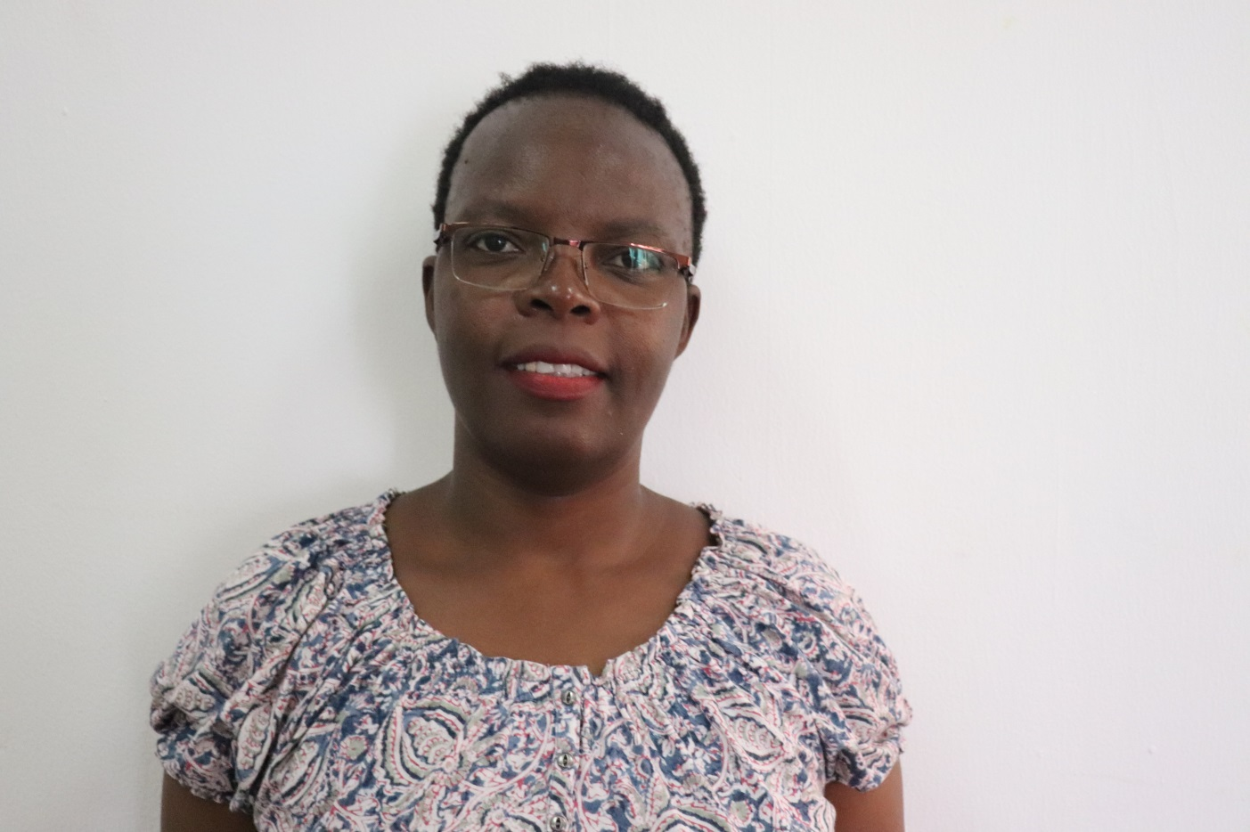

Agnes Mwangwela, Malawian
Food and Nutrition Specialist @ LUANAR, Malawi
Africa RISING – East and Southern Africa region
Having participated twice in the Africa RISING Field Exchange Visit, I expected to see the integration of Food and Nutrition activities. I also expected to see the scaling up of research on Food and Nutrition aspects.
During the Field Exchange Visit, I was happy to observe the potential use of Savings and Loans Groups for bringing in the nutritional messages.
I also appreciated the Gender and cultural dimensions that has been incorporated in the Nutrition interventions.
With regards to my input on the modification of farmers’ activities, I would like to suggest the use of sack gardens to intensify vegetable gardens and dietary diversity.

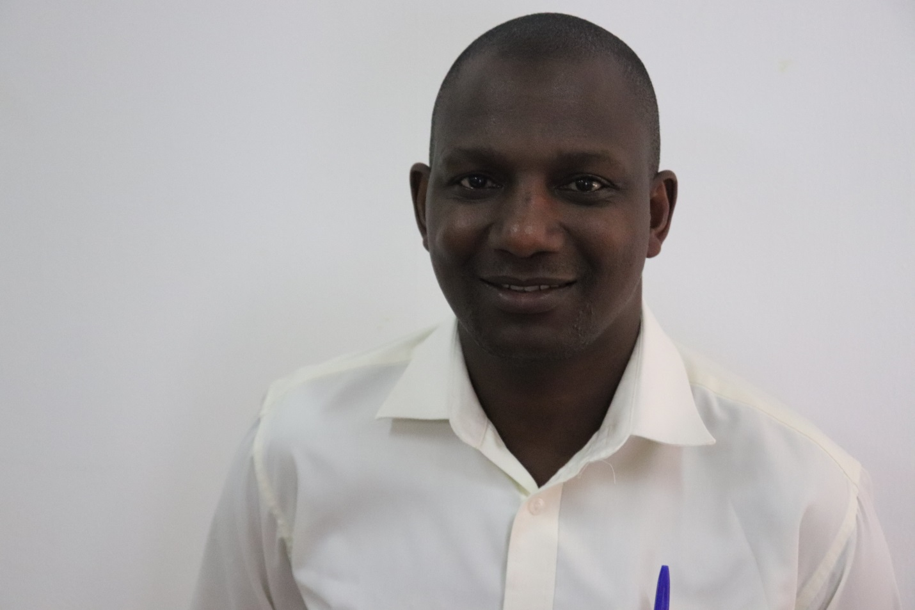

Christopher Muntungi, Kenyan
Post-Harvest Manager @ IITA, Tanzania
Africa RISING – East and Southern Africa region

I have gladly participated in the Africa RISING Field Exchange Visit twice.
Before this Exchange Visit, I expected interaction between scientists from different countries/regions working on different disciplines; overview of the kind of research they are doing and a bit of interaction with the partners they are working with.
However, this visit gave me the chance to observe an interesting engagement with public sector on technology transfer (mechanization) I was excited to see a new model for technology transfer- mechanical shellers.
I commend the great organization of the field exchange visit program. The various aspects came out; partnerships, technology transfer; farmer perceptions, group dynamics, science challenges etc. were all well rounded. Farmers’ also participated sufficiently with appreciable sense of patience.
I personally benefited from this Exchange Visit in the area of the technological transfer model being applied for the maize shellers in West Africa sub-region.

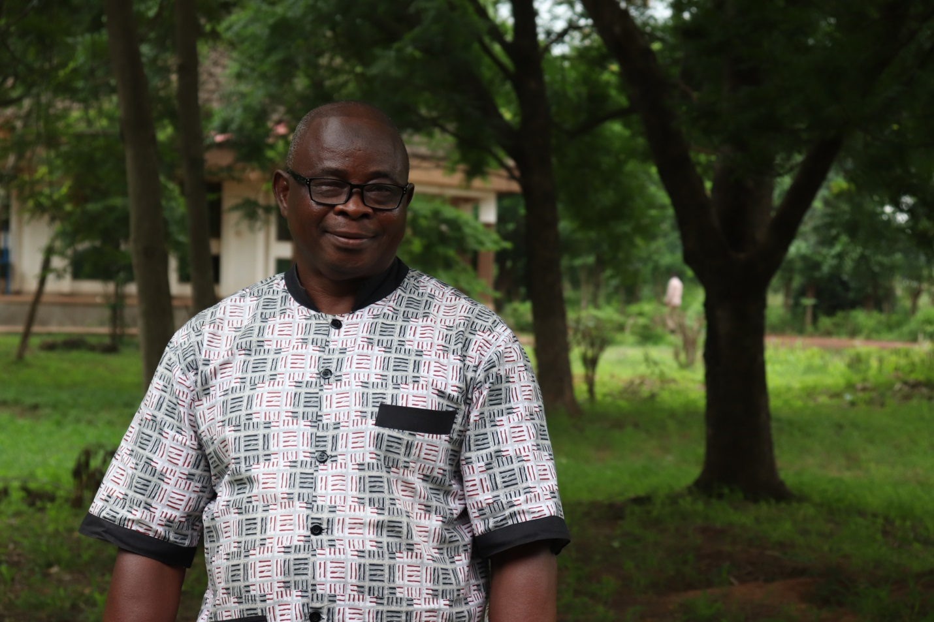

Prof Mahama Saaka, Ghanaian
Nutritionist, UDS, Ghana
Africa RISING – West Africa region

I have participated in the Africa RISING Exchange Visit just once.
My expectation was to learn from the innovations observed in the field
The Field Visit revealed that the learning sites were still in the formative stages and so activities were not to scale. For instance, the Feed troughs still need modification.
Another observation made was that most of the innovations were in their initial stages and not on full-scale
I have personally identified women’s groups that could be entry points for nutrition/health interventions

I recommend that future visits should be planned to really see dramatic innovations that are making a difference on the lives of our target population. Example Women and children
I also suggest that many more farmers should be benefiting from the technology parks or demonstration plots. Presently, one or two farmers were using the technology parks/hubs.
As a Nutritionist, I have benefited from the program. This is because the Women Group and other Farmer groups already existing in the communities are potential entry points for areas such as Nutrition education.
To conclude, I would say the scope of activities is currently on the low ebb. The same few communities are beneficiaries to Africa RISING.

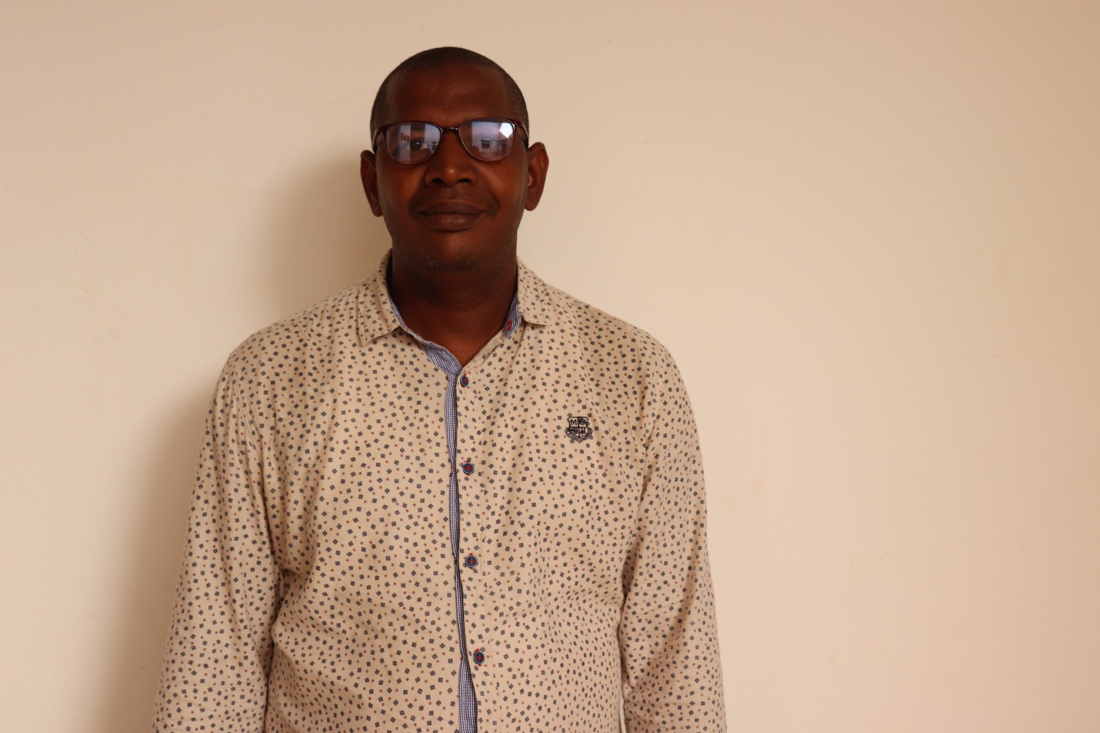

Mahamadou Dicko, Malian
Farmer Engagement @ AMEDD, Mali
Africa RISING – West Africa region

This is the first time to participate in the Africa RISING Field Exchange Visit. The Visit has been very useful for me. I learned that farmers’ in Ghana face the same challenges as in Mali.
Coming to the Exchange Visit program, I was expecting to see how the engagement of farmers in adoption/adaptation of Sustainable Intensification Framework was done in Ghana.
My observation from the Field Exchange Visit portrayed that farmers in Ghana and Mali face the same constraints. Though the technologies are very relevant to improve productivity, their adoption by farmers is still poor due to high cost of implementation. (Proposed technologies and innovation need to be refined and adapted to local contexts).
Increasing farmers’ participation in the refinement and adaptation of the proposed technologies may improve their wider adoption. It is also necessary to strengthen the capacity of local craftsmanship using local materials in the adaptation of technologies proposed by farmers.
I suggest that the active participation of farmers and continuous capacity building of beneficiaries must be encouraged to increase the uptake of SI technologies and Innovations.

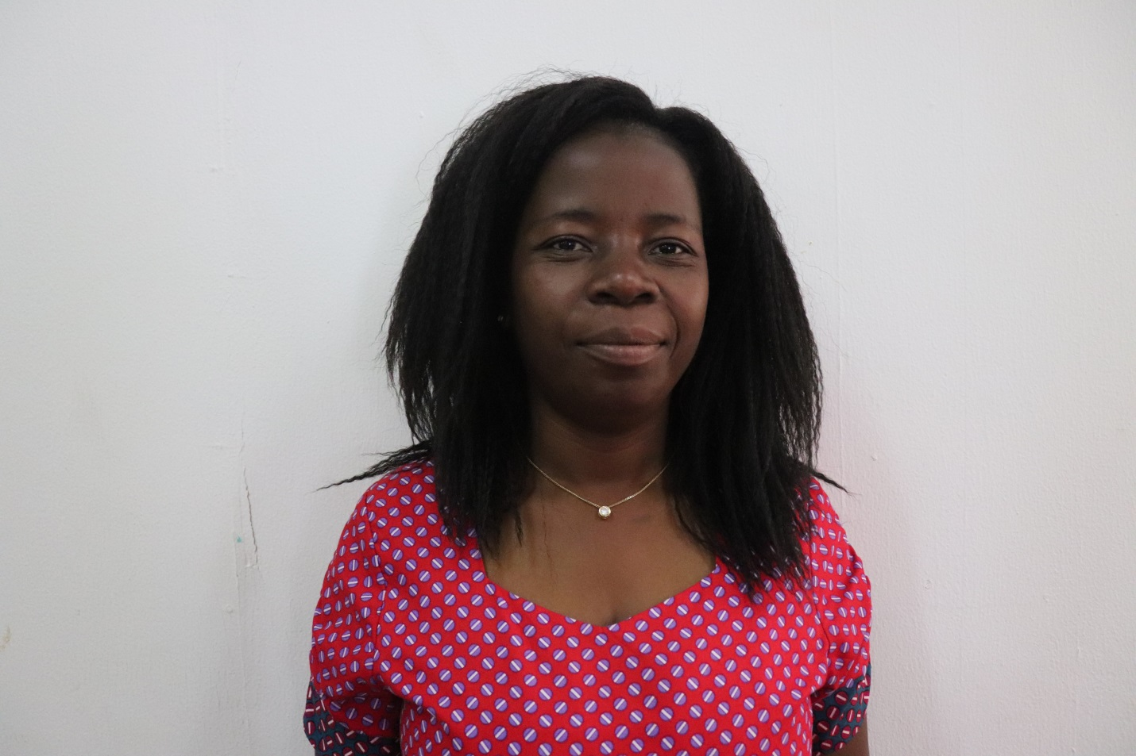

Fanny Chigwa, Malawian
Animal Nutrition @ LUANAR, Malawi
Africa RISING – East and Southern Africa region

This is my first time to participate in the Africa RISING Field Exchange Visit program. The Exchange Visit was educative as it introduced me to Improved Feed Troughs and Group Model of Maize Sheller Management and owning system.
My expectations included learning and observing which technologies could be used with modification for livestock intensification in Malawi.
During the Field Exchange Visit, I observed the following:
- Feed trough technology
- Group model in mechanization of smallholder farmers
- The program was a good learning event for regional integration in research
- I recommend the adjusting of Feed trough to match animal size, feeding behavior, farming system for efficient feed utilization packages.
In addition I suggest the following for the Feed Trough:
- Use it and adjust for animal sizes
- Use along with forage chopping technology
- Promote total mixed ration
- Add modification to destruct goats from jumping into trough
Upon return to my project country, I intend to share the Feed trough technology to promote sheep, goat fattening for the market, goat marketing, and also group model for mechanization.

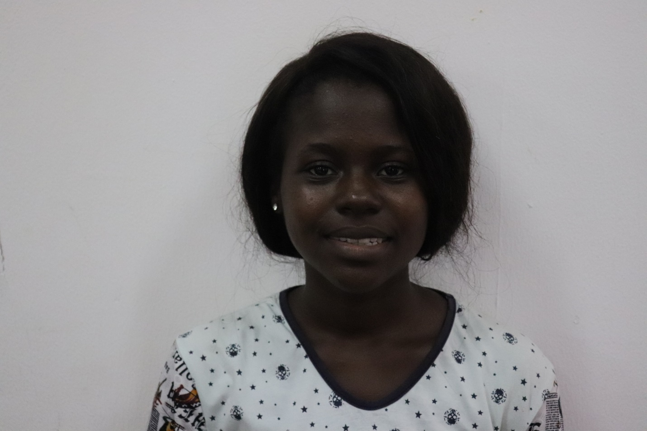

Ernestina Annan, Ghanaian
MPhil Student (Land and Water Management) @ KNUST, Ghana
Africa RISING – West Africa

This happens to be my first participation in this Field Exchange Visit program. The program has been very helpful as it gives members of the project an opportunity to really catch up with what is done in other parts aside their countries, and it enables members to learn from each other on research for development projects.
Coming to the Field Exchange Visit program, I expected that the nationals from other countries were going to have a look at what was going on down here, but it happened to be more.
During the Field Exchange Visit program, I observed that not only was there a demonstration to the other nationals, but there was idea sharing and exchange of knowledge which I found to be very impressive and worth partaking in.
I therefore commend on the idea of such a program; it is very thoughtful and worth the while. I also commend on the organization of farmers; it was work well done.
I suggest that it’ll be good to see some of the technologies and techniques presented to farmers, locally constructed by them using local materials so we know with evidence that truly they can do this on their own.
It’ll be good to have information on what has been done in the past years since Africa RISING began. I think the Paper Reviewing for the various disciplines is a good step to achieve wider impacts and knowledge of what is being done in Africa RISING.
In all, this program has been a great experience for me.
Thank you.

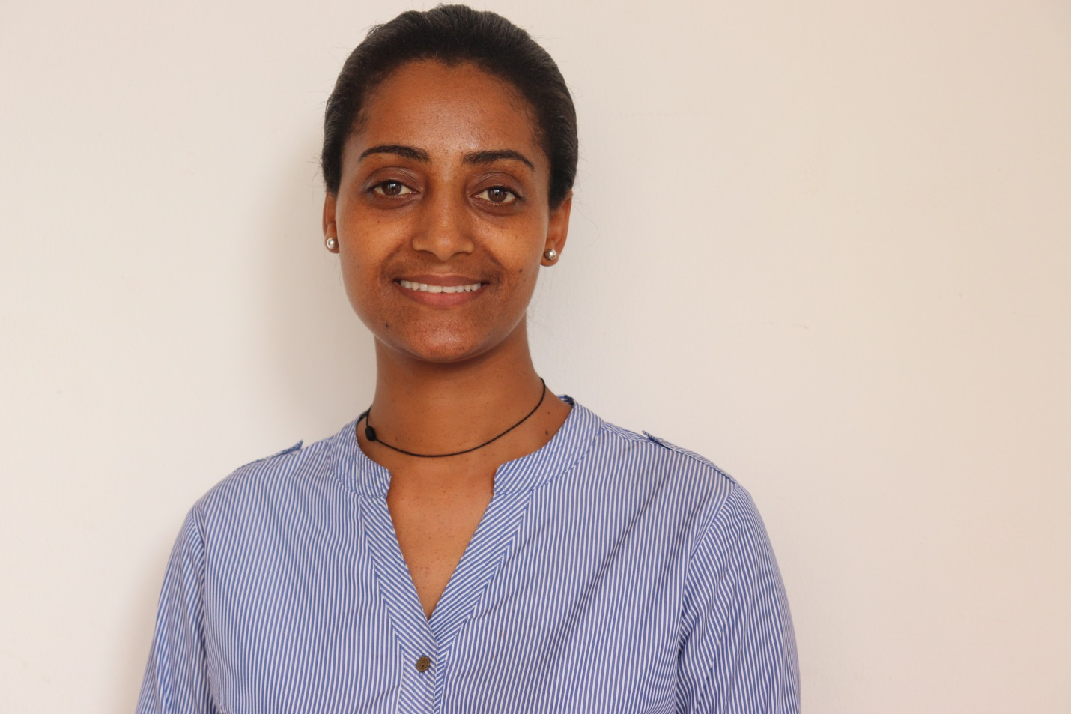

Mestawet Gebru, Ethiopian
Nutritionist @ Bioversity, Ethiopia
Africa RISING – Ethiopian Highlands

This has been my first time in participating in the Africa RISING Field Exchange Visit program. It was very interesting. The visits were unique and the discussions afterwards were very helpful to learn from the other countries’ experience.
Prior to my participation, I was expecting to see more diversified fruits and vegetables in the farmers’ gardens which I find as a gap in the project.
My observation of the feeding trough and the maize shelling machine was impressive. It was my first time to see it and I found it very innovative.
However, in the area of Nutrition, I didn’t see many varieties of vegetable and fruits. From my observation the farmers’ diet may not be diversified as they mostly eat what the produce.
I commend on the A-frame approach for making contours in farmers’ fields as an erosion prevention measure; and the radio approach to convey nutrition message to communities.

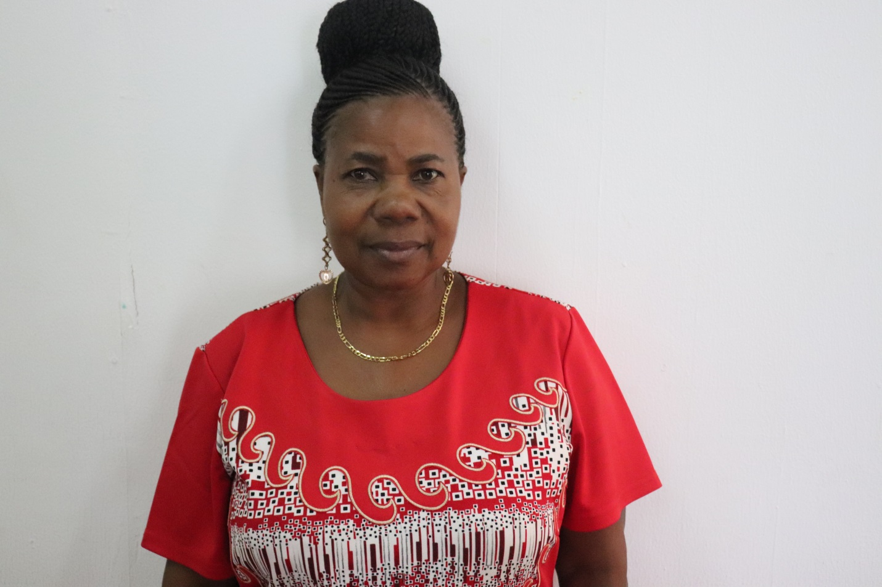

Prof. Yasinta Muzanila, Tanzania
Nutritionist @ Sokoine University of Agriculture (SUA), Tanzania
Africa RISING – East and Southern Africa region

I have participated in the Africa RISING Field Exchange Visit program twice. It was very useful and educative. I have found the Field Visit to be very good and I even liked the way members were asking questions and probing for more information.
Through the Africa RISING Field Exchange Visit program, I expected to meet farmers and learn how they implement Africa RISING project activities. And my expectations were met.
I observed the Improved Feed Trough for the first time. I have found them to be very efficient in terms of feed loss prevention.

I commend on the different places (communities) visited; we could see how different communities work.
I suggest that on the irrigation scheme, they need to use drip irrigation to save the water.
What I found worth sharing was the Nutrition messaging on the radio, which they say that it is in form of drama. This could be a useful way of disseminating information. While someone is enjoying the drama, they are also learning at the same time.
Also, I liked the way the women (women group) were readily giving answers to questions they were being asked. They were very interactive, looked confident and really empowered.

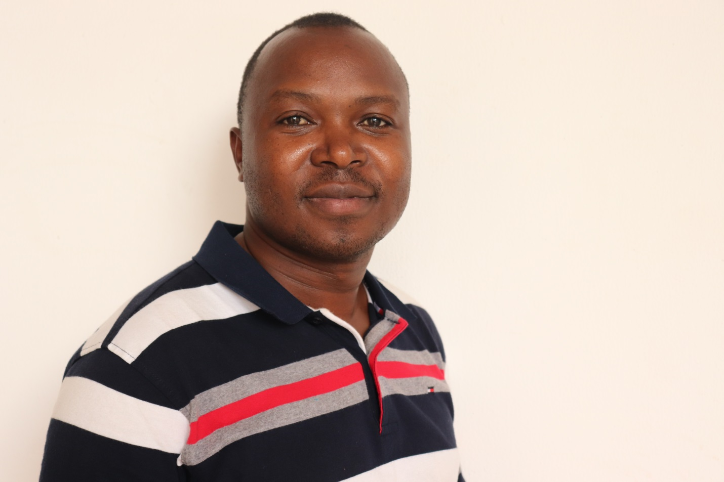

Justus Ochieng, Kenya
Impact Evaluation and Scaling @ World Vegetable Centre
Africa RISING – East and Southern region

I have participated in the Africa RISING Field Exchange Visit program on two occasions. The exchange visit was well organized. Good work was being done with farmers in different villages visited.
As I was coming to participate in the program, I was expecting to learn different approaches to deliver nutrition messages to farm households.
From my observation, it was a very nice approach to see that what we have used in Tanzania is being used to transfer mechanization technology to farmers (farmer group approach).
I have shared the SILC (Saving, Internal Lending Communities) training manual with Bekele, to be used in training farmer groups receiving maize sheller machines.
In my opinion, in future, there is no need of including farmers’ participation in such visits. Only lead farmer or leaders may participate in Africa RISING Field Exchange Visit program.

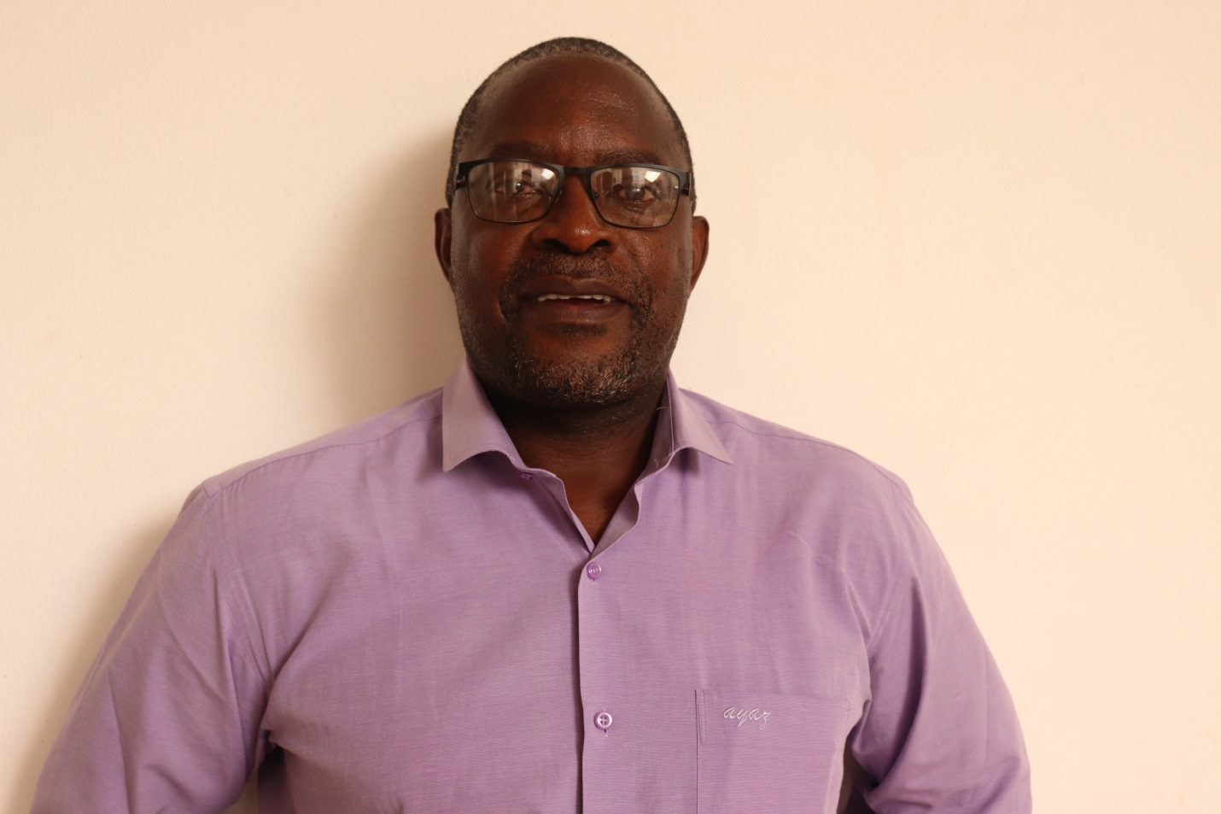

Walter Mupangwa, Zimbabwean
Mechanization and Soil Scientist @ CIMMYT, Ethiopia
Africa RISING – East and Southern Africa region

I come from Zimbabwe, and I work in CIMMYT in Ethiopia. On the Africa RISING project, I work in the area of Mechanization and Soil Science.
This is my second time of participation in the Africa RISING Field Exchange Visit program. The visit was well organized and we had good interaction with farmers.
My expectations were to learn from the activities of the West Africa region, covering different aspects of sustainable intensification.
From my observation, there were common challenges in the different regions; and there was scope in working together more closely. Also, collaboration of Africa RISING researchers with government, research and extension staff was not clear during the whole visit.
I recommend the widening of partnerships, example, including more private sector partners in order to set the ground for sustainability after Africa RISING project has ended.
In addition, I suggest that farmer activities should reflect more integration of the SI technologies that are being promoted in Africa RISING program.
I find the group model in mechanization worth exploring in Ethiopia based on the Ghana experience.

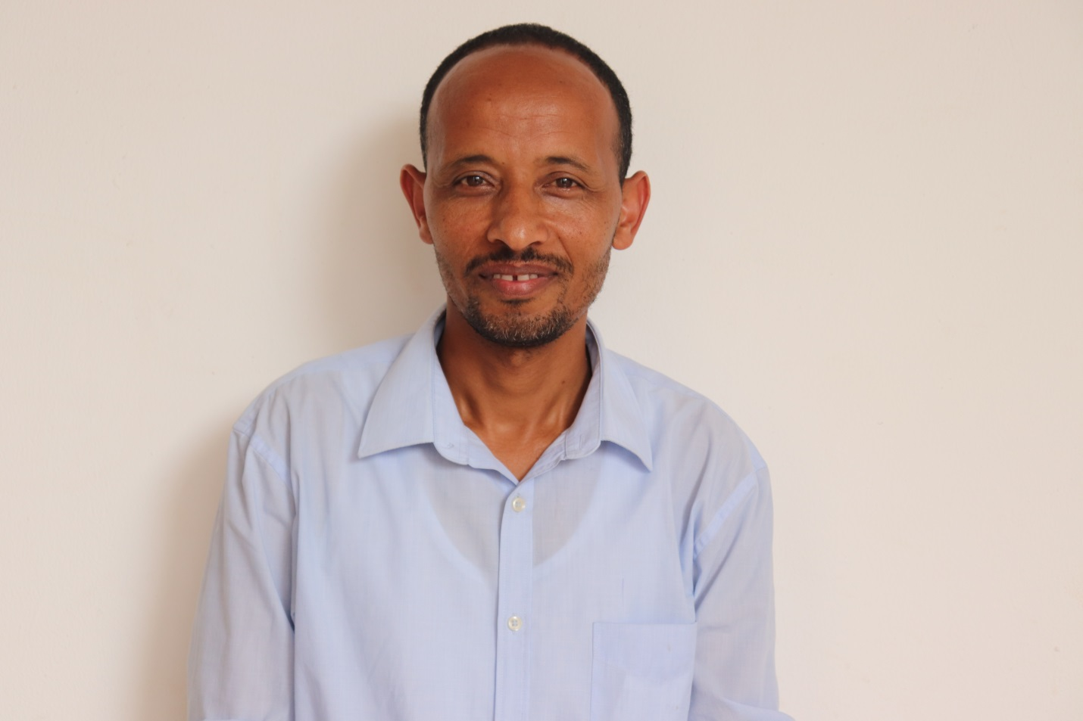
Melkamu Bezabih, Ethiopia
Livestock Feeds and Nutrition @ ILRI, Ethiopia
Africa RISING – Ethiopian Highlands

I am an Ethiopian, working in ILRI, Ethiopia. I work on Livestock Feeds and Nutrition on the Africa RISING project.
This has been my second participation at the Africa RISING Field Exchange Visit program. It was a very good experience.
My expectation was to interact with researchers and farmers about the on-going research and adoption of technologies. I was also expecting to see how the farming system looks like in this region.
Through the program, I got a good understanding of the farming system and traditional practices
The visit was good. The demonstration of feeding troughs and threshers is very important. Targeting women groups was one interesting aspect of the visit. It is necessary to strongly work on these.
I suggest the following:
- On feed troughs- demonstrate with locally available simple materials
- Adjust dimensions based on the animal types
- Train farmers how to use the troughs
I think it would be worth integrating Feed Troughs with forage cultivation, ration optimization and training farmers for market oriented animal production.
Furthermore, a trough has a limited capacity to serve at a time. It may be 10 or 12 or 6. So it should be used accordingly. In one of the farmers we visited, about 30 animals (groups of sheep) were channeled to one small trough and no animal was able to eat anything. The visitors considered it as the troughs were not liked by the sheep. But the problem, there is the way we handle animals. On the other hand in the first form it was used perfectly.
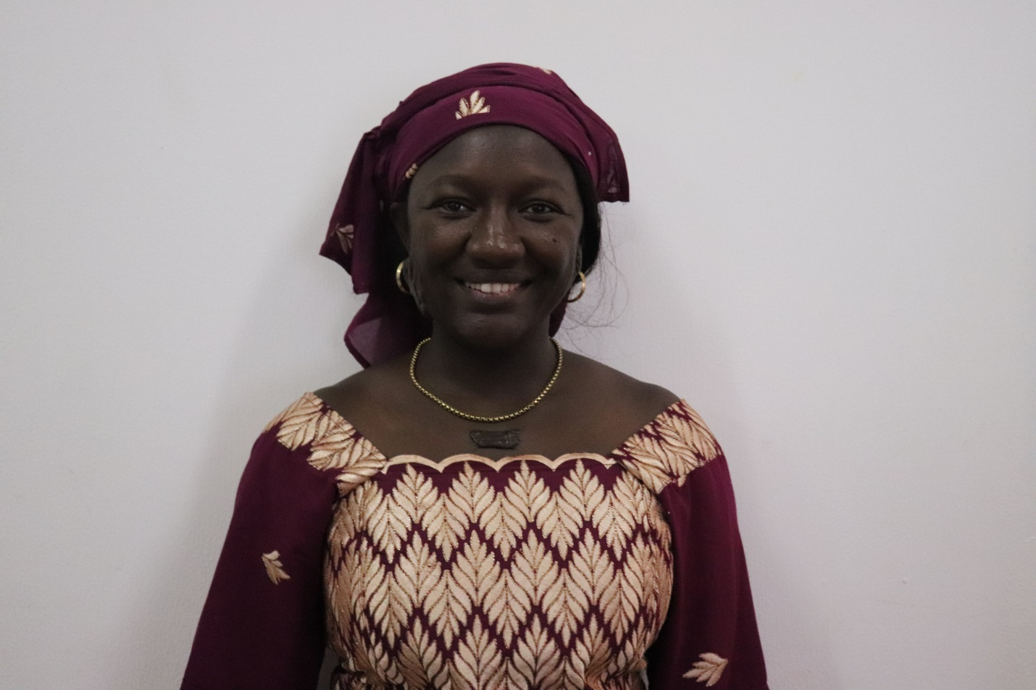

Madina Diancoumba, Malian
Crop Modeling (PhD Student) @ ICRISAT, Mali
Africa RISING – West Africa region

I have participated in the Africa RISING Field Exchange Visit program twice. Generally speaking, I found the visit interesting. I learned a lot particularly on the mechanization aspect. I was glad to see that farmers could easily have access to the manufacturer and expose their needs, that is to say modifying some parameters of the shelling machine for example and be sure that those needs will be fulfilled.
I was expecting to see more than one activity per site, more integration between those activities and a greener technology park. I was also expecting to hear more on animal health as was mentioned in the program.
I was impressed by the grant provided by Africa RISING to the women group. I hope this will be the entry point for Africa RISING to introduce some of the already developed technologies to them. Moreover, I was surprised to hear that attacked vegetable leaves by pests are appreciated in the market.
Concerning modification, as it was mentioned during the visit, it would be good if farmers could take into account the feed type (depending on the season) and the size of the ruminant fed while building the feeding trough. They could also think of building a drinking trough using their local materials as they intend to do with the feeding trough.
Also, it would be good to test using crop models, the irrigation technics presented in the vegetable hubs and probably explore more irrigation options and assess the impact of each technic on crop production.
Next time, I would like to see more integration activities in the visited sites.

